News 19 Nov 2018 / https://www.futurefarming.com/Tools-data/Articles/2018/11/New-easy-to-operate-affordable-crop-sensor-by-Fritzmeier-360914E/

New easy to operate, affordable crop sensor by Fritzmeier
German manufacturer Fritzmeier Umwelttechnik is currently developing a new easy to operate and affordable crop sensor for farmers growing 100 ha or less. The company says everyone can learn to operate it within 15 minutes.
Most of you will know Fritzmeier as a cab manufacturer and as the developer of the Fritzmeier Isaria and Claas Crop sensors. The main difference between the red Fritzmeier and the green Claas equivalent is the Isobus compatibility of the Claas version.
So far, according to Fritzmeier, 400 Isaria sensors and 200 Claas sensors are in operation. In order to increase its market share Fritzmeier says, an easy to operate and affordable sensor is needed.
Text continues underneath image
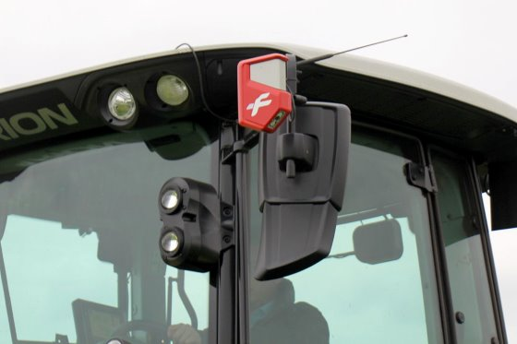
The new Fritzmeier Isaria Basic crop sensors are easily fitted to tractor’s mirrors to warrant universal use. - Photos: René Koerhuis

Daylight sensor
The new Isaria Basic sensor as it is called, will premiere at next year’s Agritechnica. Until then, 15 sets are tested in various European countries. The main difference with the existing Isaria sensor is that its Basic alternative comes without an active light source which means the Basic version can only be operated during daytime with sufficient daylight present.
This approach is interesting, as Yara recently introduced a new active crop sensor. The company earlier hinted that it might focus on active sensors completely and stop delivering the passive daylight sensor.
Text continues underneath images

- 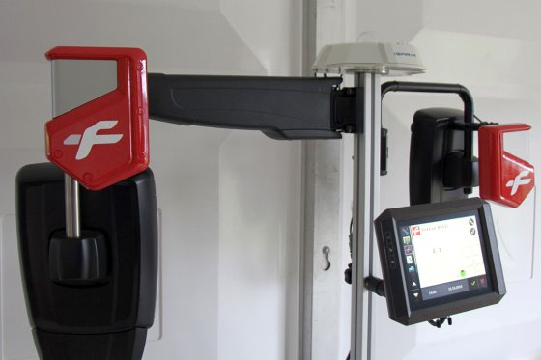
The total package consists of 2 crop sensors, a cab roof fitted gps-system and light
sensor and a Fritzmeier or Isobus terminal.
- 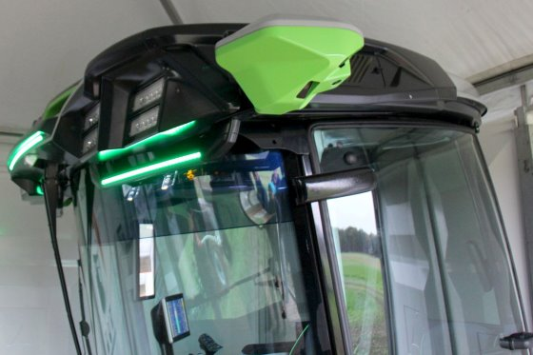
Also made by Fritzmeier, the new SmartCAB with rear view
cameras instead of mirrors, and, with integrated crop sensors!

Isobus compatible
Fritzmeier says the Basic crop sensor is intended for every farmer growing 100 ha or less. It is (indeed) easy to operate, Isobus compatible and it’s fitted easily on for instance tractor’s rear view mirrors to warrant universal fitting to any type of tractor/vehicle. The retail price is targeted at around € 12,000. According to Fritzmeier, crop sensors can help create a € 60/ha extra margin in cereals.

